Dual-Stack is a hosted solution with Talaria TWO Wi-Fi module which helps replace the normal Wi-Fi driver concept of Linux stack. This solution is designed to reduce power consumption without compromising the throughput performance for Linux based application SoCs used by ISPs, Industrial computers etc.

Dual-Stack provides the following advantages:

1. Maintains Wi-Fi connectivity during host power off/sleep state.
2. Supports low power.
3. Easy to migrate across different kernel versions.

In this solution, the Wi-Fi driver software runs in the user space with minimal kernel modifications and makes use of the network stack on the Wi-Fi module for housekeeping tasks (such as cloud keepalive). The network stack on the Linux host is used to transfer high bandwidth data.

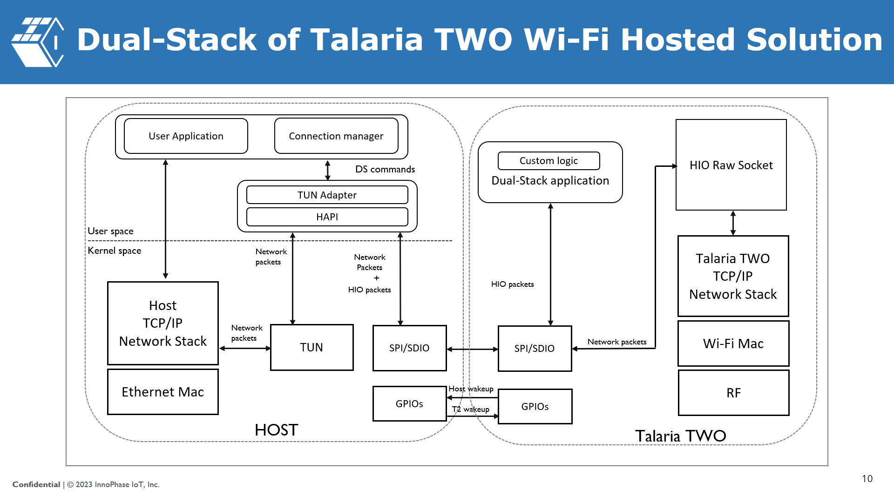

Figure 1: Software architecture block diagram

Following are the key advantages of the Dual-Stack solution:

1. Solution is a user space program and hence easy to maintain.
2. Portability across platform and kernel versions.
3. Linux kernel modifications are minimal to support SPI/TUN.
4. Existing socket applications will be able to run on the host without any modification.
5. It provides a shadow service of sockets so that the always connected feature can be achieved even when the host is in sleep.
6. FOTA and provisioning features are supported.